**1. Connect HR system to Auto provisioning users every 30 minutes. Create in AD and Entra. With all attributes populated.**

//incomplete but not used hr system and doesnot sync to entraid done with bulkusers in AD

Steps:

1.Integrate HR System with Microsoft Entra ID:

2.If the HR system supports API integration (e.g., Workday, SAP SuccessFactors), enable auto-provisioning via Microsoft Entra ID.

3.If no API, automate CSV-based imports using PowerShell scripts .Configure Automatic Provisioning in Entra ID:

4.go to windows and search for task scheduler and select create task and select the checkbox (run when user is logged or not and select high privileg permissions) then in conditions start the task for every 10 , 15 , 30 , minutes and 1hr then select ok set time for 30 minutes

5.If On-Prem AD is involved, use Entra Connect Sync and configure a 30-minute sync cycle.

Use PowerShell script (New-ADUser)

**2. ⁠Move users from one location to another and assign new access. // now iam doing this with csv file in AD and changing ou users location.**

Steps ➖

1.First we need to Identify Users to which location they are moving

2.Fetch data from HR system ( or CSV).

3.Compare existing user attributes (Location, OU, Department).

4.Modify User Location in AD & Entra ID:

5.Use PowerShell script (Move-ADObject) to update AD OU.

6.Modify Entra ID attributes through PowerShell

7.Reassign New Access Groups & Permissions

8.Remove user from old AD security groups and add them to new location-specific groups.

9.Update Microsoft Entra ID Conditional Access policies based on location.

10. In entitlement create catalog and access packages that will validate Access Reviews and access changes.

// to move users from one ou to another ou use command called

“Move-adobject -identity “CN=ram,OU=domain,DC=megthink,DC=com” -targetpath “OU=domain,DC=megthink,DC=com”

11. Now users got moved from one ou to another ou now we need to update location.

PS C:\Users\Administrator> set-aduser -identity "yash" -state "afganistan" {here we will set location to a user }

PS C:\Users\Administrator> Get-ADUser -Filter * -Properties state| Select-Object SamAccountName, GivenName, Surname, state| Export-Csv "C:\powershell\UpdatedUsers.csv" -NoTypeInformation {this command updates the users location}

This is the old csv file and the OU is not changed

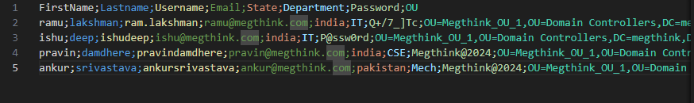

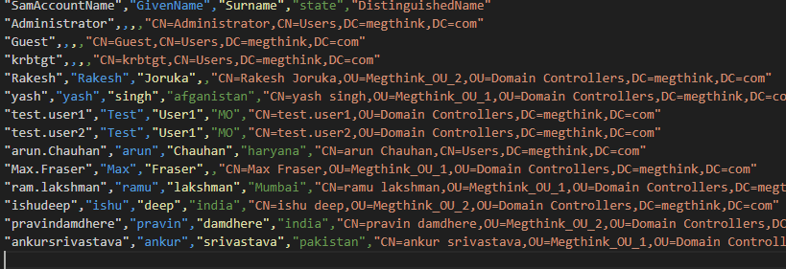

In the above screen short you can see updated location and changed ou (eg:- pravin and ishu)